Aerial Robotics Kharagpur Selection Task – Perception
Task 2.3: Medial Axis Detection of Moving Objects
Harsh Raj, First Year Undergraduate, B. Tech, Computer Science & Engineering

Abstract - This documentation contains my solution to the medial axis detection task. Here, the objective was to detect the medial axis of a moving object in given video inputs. The detected axis is then drawn to each frame of the input. Here I have used opencv and numpy for intitial operations and have developed a method to apply hough line transform without using the library method of this transform.
Clearly, these are essential in machine learning as well as understanding of the environment for controls. Either it is background subtraction, edge detection or hough line transform, all are used in detection of path, objects etc in the environment in real life projects.
I. INTRODUCTION
Our objective was to process given video inputs and highlight the medial axis of a moving surgical tool on each frame. And overlay the axis on the original video. This required us to apply background subtractor, Image Cleaning, Edge& Line detection and Medial Axis Localization using the line transform by scratch. The major constraint was to write the line transform code form scratch. Here I have used the basic logic behind the hough line transform i.e using accumulator space.

II. PROBLEM STATEMENT
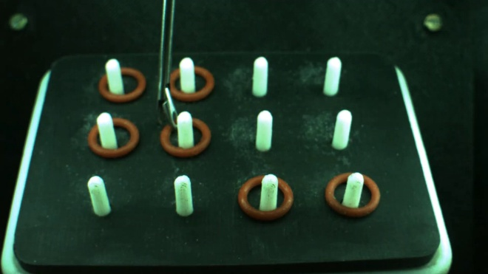
The problem statement is input of video of a moving surgical tool against largely static background. The required outputs are: foreground detection using the background subtractor and then denoising each frame and then detect
Original Frame with the Tool.
the edge and then detect the medial axis using our own function and draw the medial axis line on each frame, and output the video with detected line.

III. INITIAL ATTEMPTS
In the part of cleaning, I tried to apply many filters like median blur to remove small noises and however gaussian blur worked better for applying canny edge detection. I also tried sobel derivatives however canny worked better, with sharp edges. In part of line transform, I tried to apply basic idea of hough line transform i.e to create the (rho, theta) accumulator space and using voting find the peaks for edges. However, the time complexity was too much to handle by my hardware. Applying it individually on a frame worked but while getting video input and then applying it on each frame was like billions of operations on each frame. However I improved the method using inbuild features of numpy for example while finding peaks in accumulator space, either one can iterate over the kernel about all the pixels which gives TLE or one can just dilate the accumulator space, whichever pixel is peak will make all the pixels around it as the same, so we only has to do one-to-one matching of dilated accumulator space and the original space. Also, when trying to find the pixels with 255 initially either one can iterate over all the pixels or just find them using numpy inbuilt function numpy.nonzero, also instead of finding xcostheta + ysintheta for every x,y with 180 angles, one can just use np.outer this helps in faster calculation than manual iterative method and many more.
IV. FINAL APPROACH
Step 0 – Frame Extraction – I have used inbuilt cv2 video capture object for this and extract frames of the video input.
Step 1 – Background Subtraction – I have applied BackgroundSubtractorMOG2 function of the cv2 library.
Step 2 – Denoising the Frames – Denoising was hard the background subtraction provided the frame with the object required having having the same properties as that of noise, like the salt noise is there but if we apply opening than the actual object also fades. So, I have applied opening until the extent the required object is not distorted.
Step 3 – Edge Detection – I have applied canny edge detection, while sobel derivative also worked fine for this task.
Step 4 – Line Detection – I have used the theory behind the hough line transform and applied it with opencv and python to detect edge lines, at last I have taken average of the lines so that one medial axis remains, otherwise in hough line transform multiple parallel lines appear.
V. RESULTS AND OBSERVATION
The background subtraction stage successfully isolated the surgical tool in most frames. Morphological Opening effectively removed small noise without destroying the desired object.
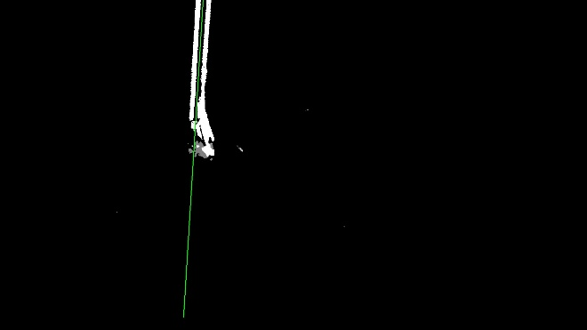
Hough Line on Canny Detected Image.
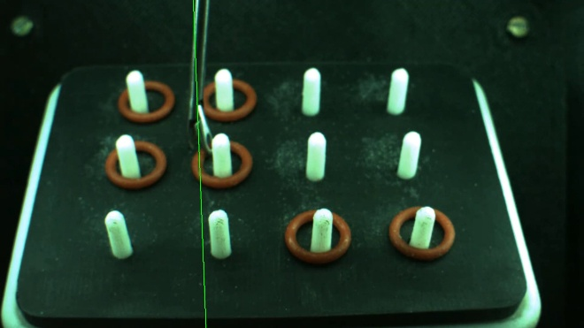
Hough Line on Original Image.
The custom Hough Transform also works fine giving lines using the accumulator space by finding the local maximas.
The averaging of all the lines provides clear medial axis, as most the lines were parallel to the medial axis, however it does deviate for the centroid of the tool at moments.
VI. FUTURE WORK
Several improvements are required, as the output is yet not as par with the probabilistic hough line transform.
VII. CONCLUSION
It was interesting as well as challenging doing these tasks and getting to know about different algorithms in opencv. Through these tasks I got to learn about background subtraction, morphological transformations, derivatives, accumulator based hough line transform approach and many more.
REFERENCES
[1] OpenCV Documentation.
[2] OpenCV Tutorial byProgrammingKnowledge.

